MODEL PRACTICAL EXAM

NAME : C.AKHIL

REG N0 : 192110244

COURSE CODE : DSA0163

SET : 4

Question paper :

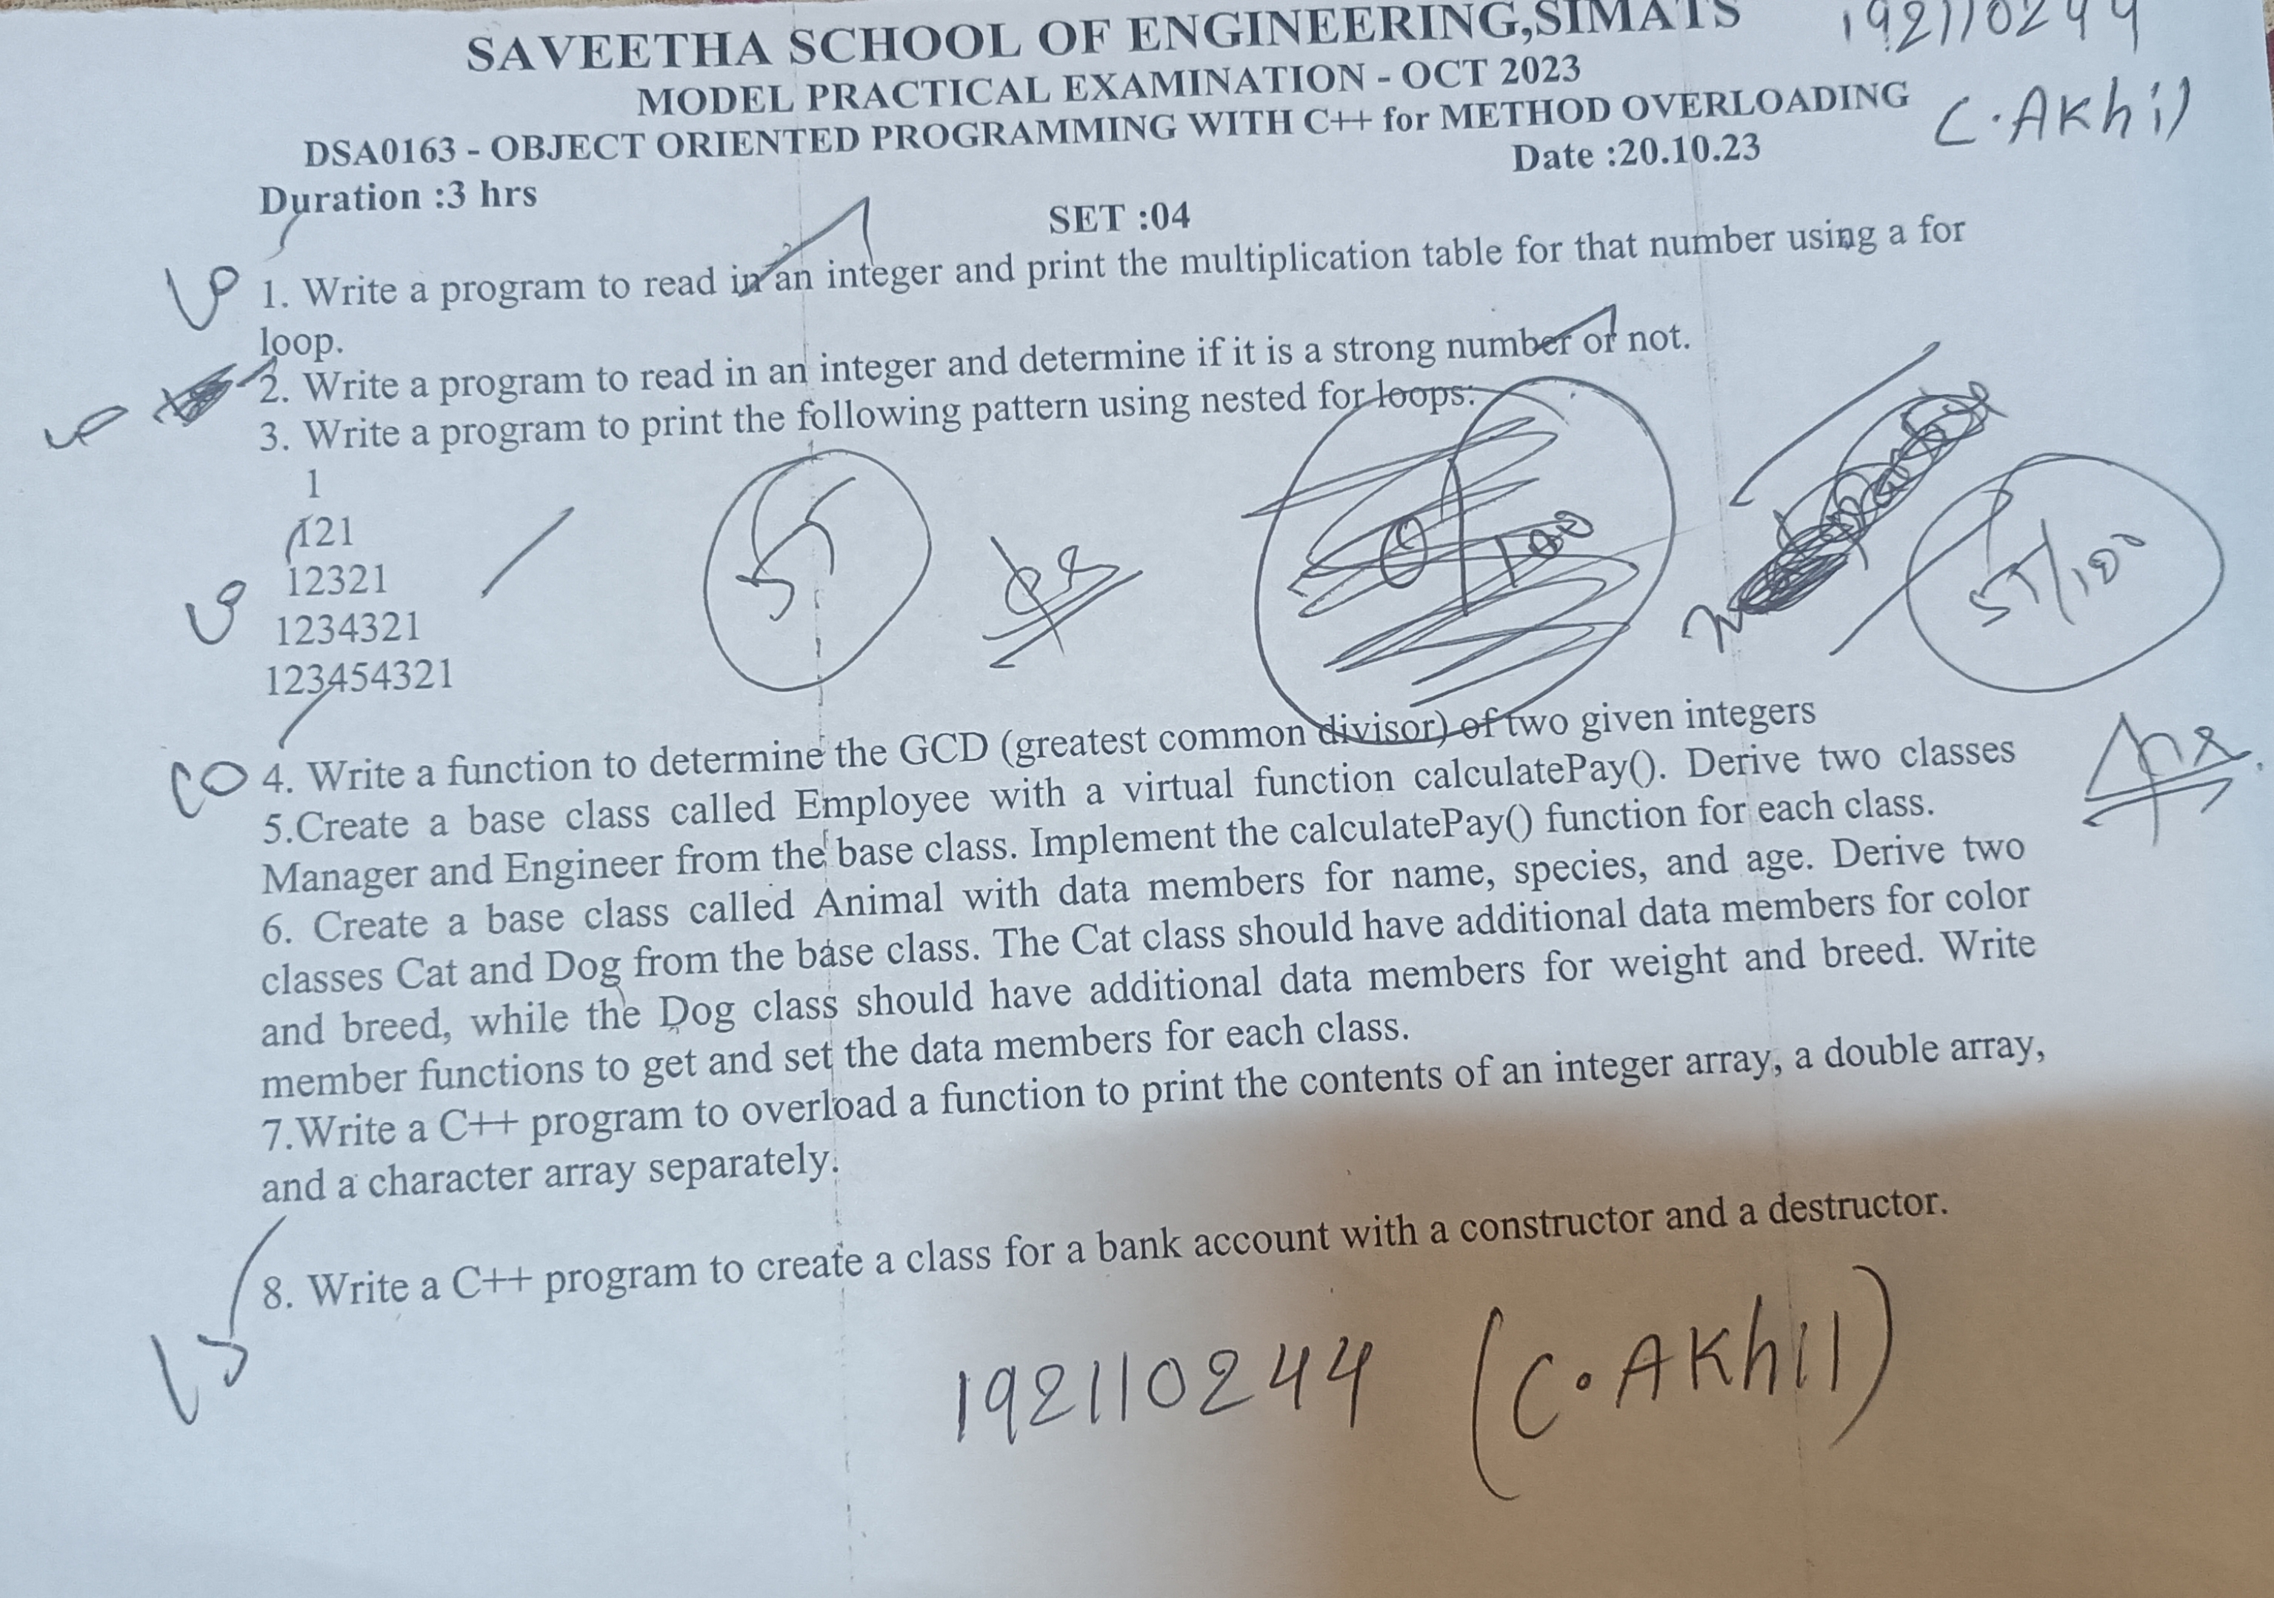

Q1) write a program to read in an integer and print the multiplication table for that number using a for loop

program :

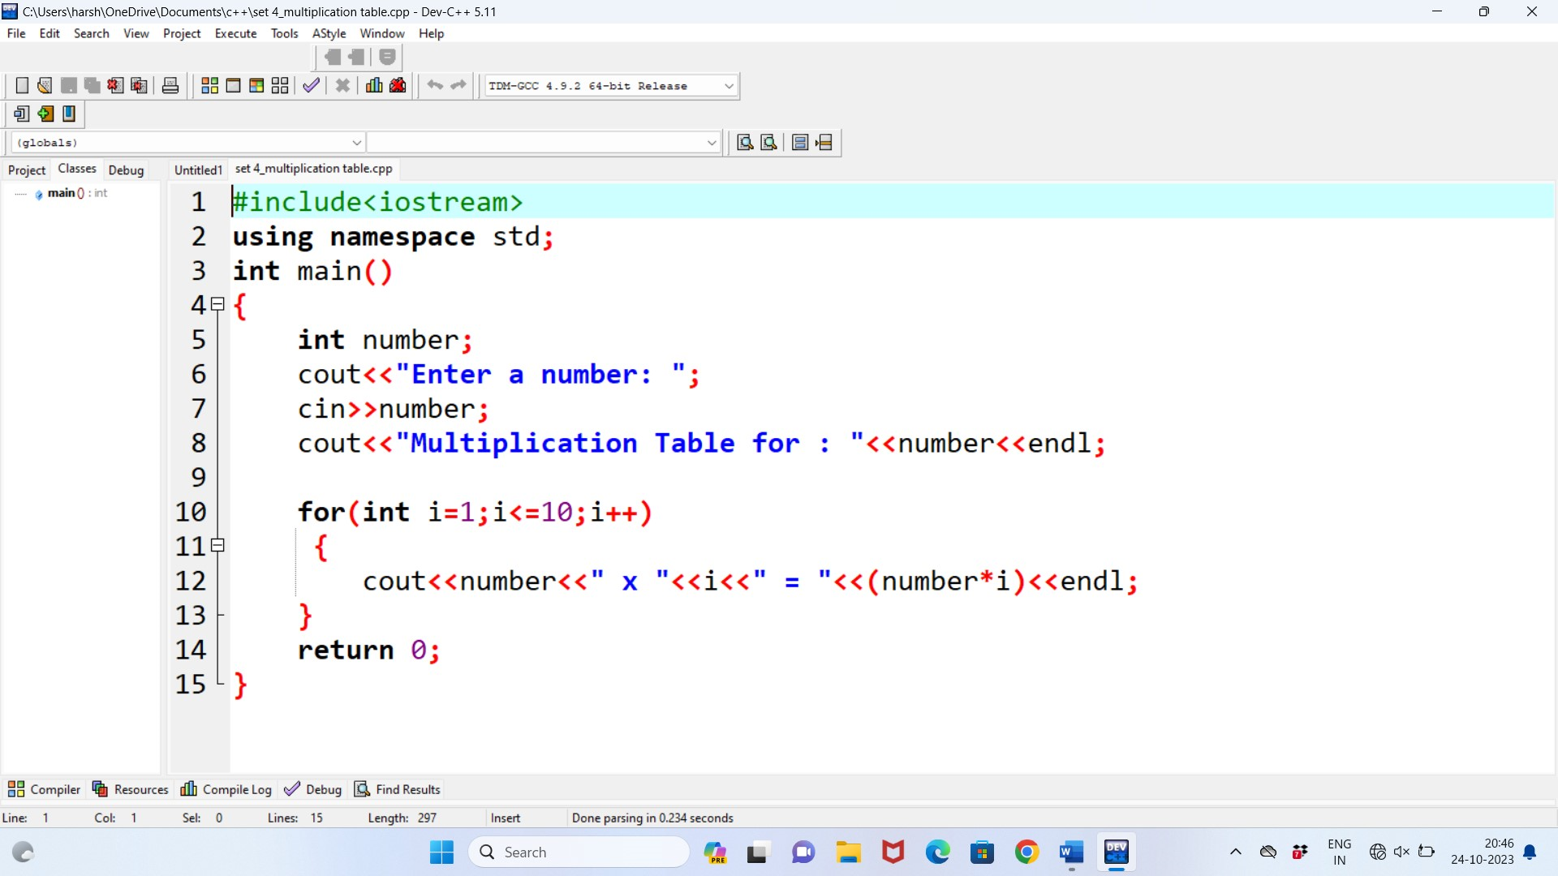

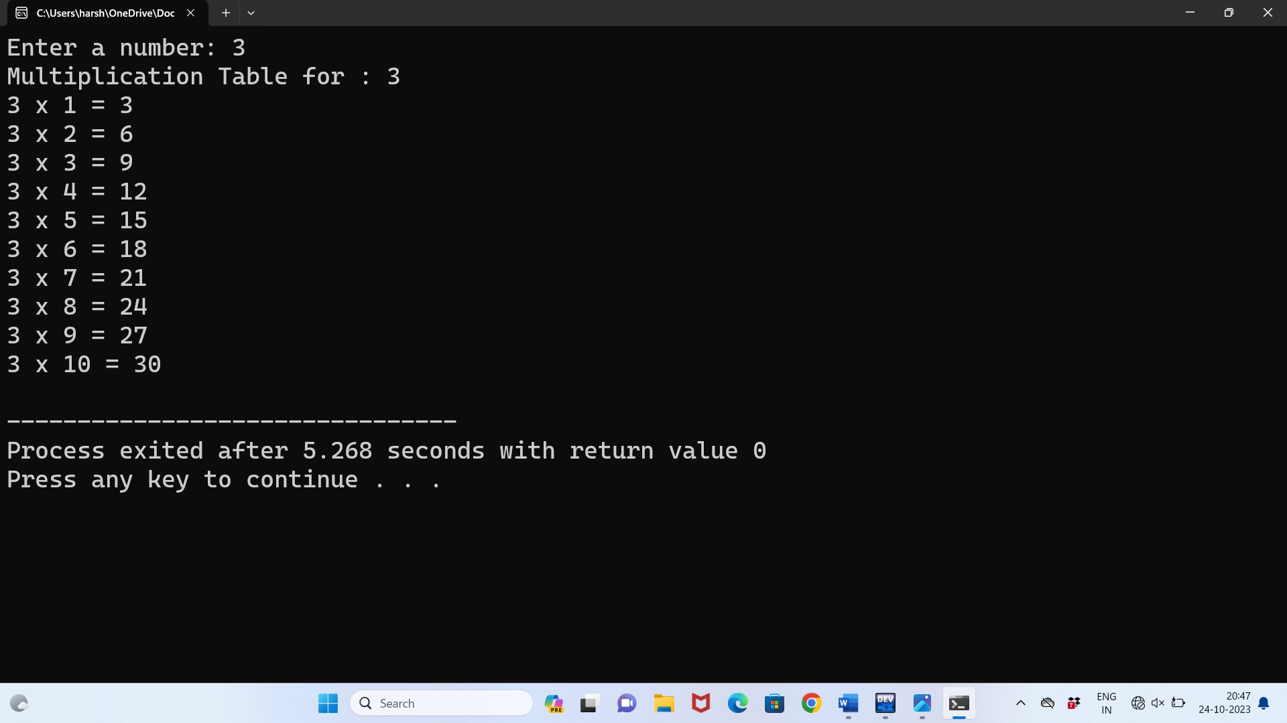

Q2) write a program to read in an integer and determine if it is a strong number or not.

# program :

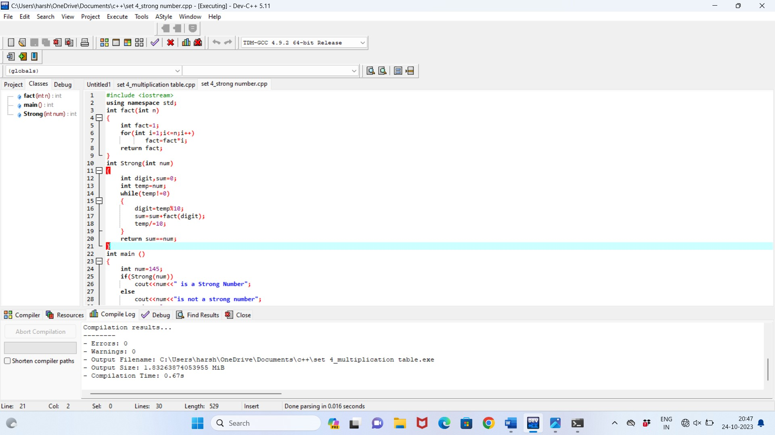

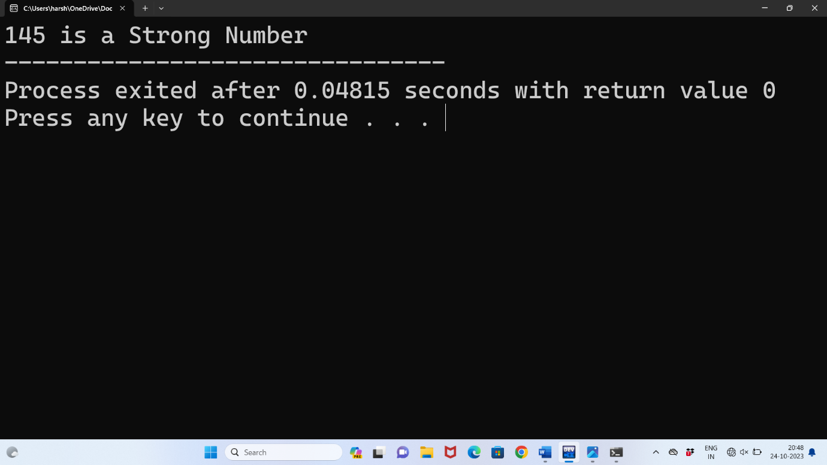

**Q3) Write a program to print the following pattern using nested for loops.**

# Program :

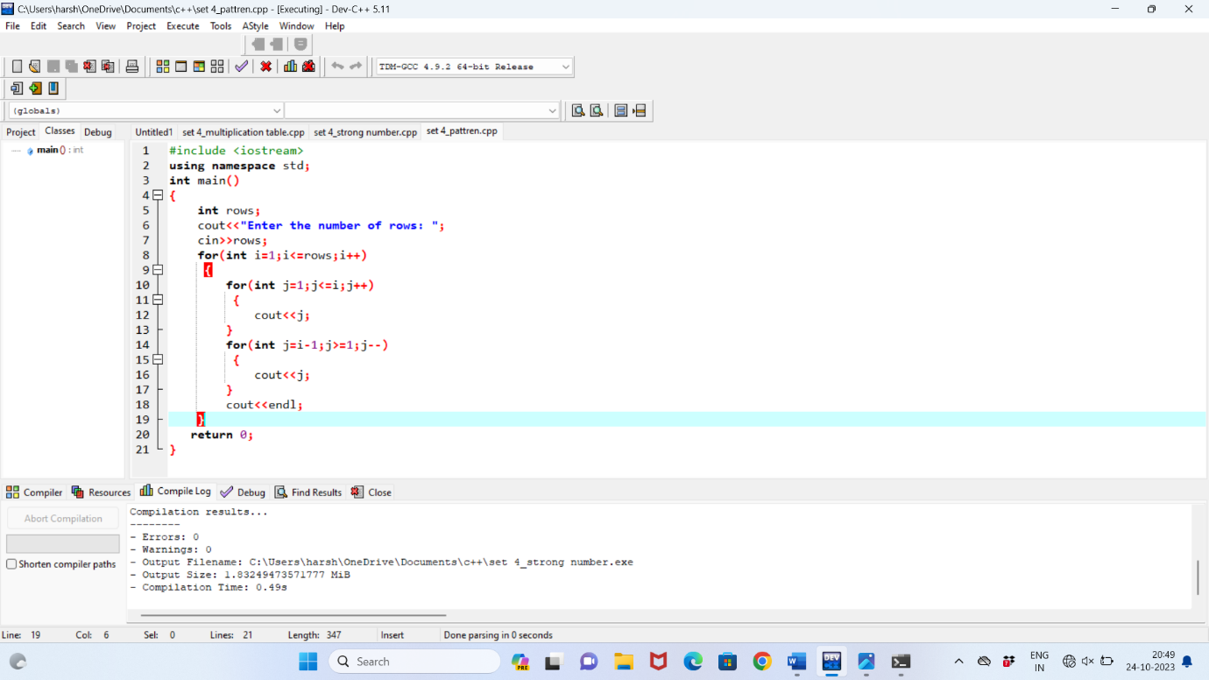

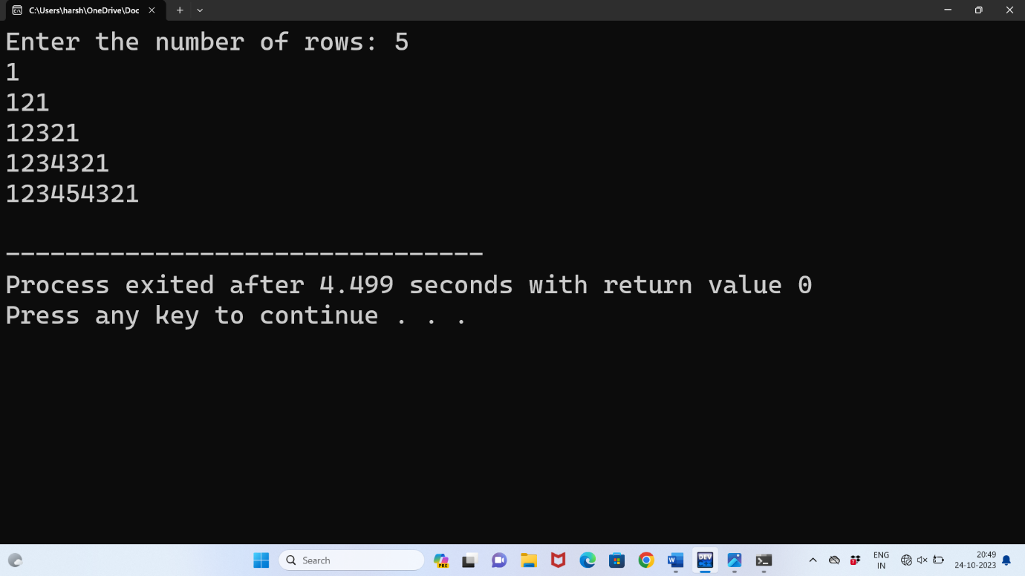

Q4) Write a function to determine the GCD (greatest common divisor) of two given integers.

program :

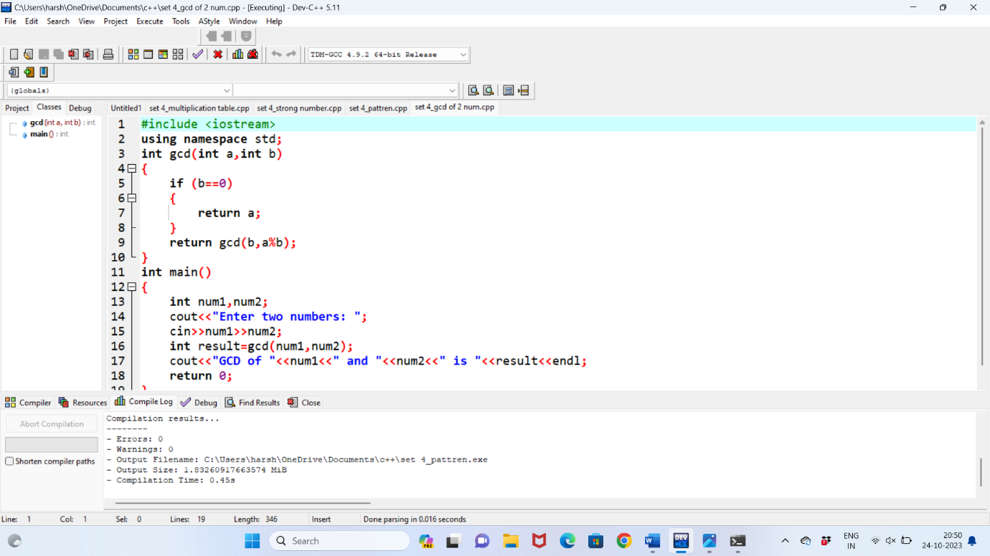

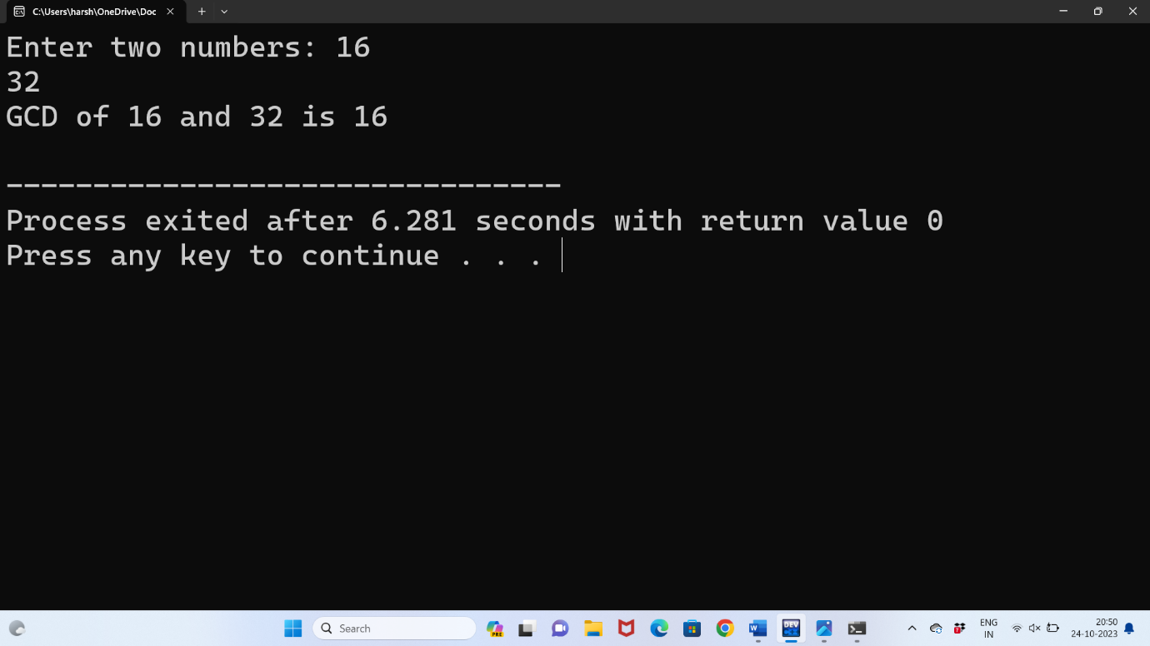

**Q5) write a c++ program to create a class for a bank account with a constructor and a destructor.**

program :

